**COMPUTER ENGINEERING**

**Title of Micro-Project:** Micro-Project on Embedded System.

**GROUP MEMBERS**

|  |  |  |
| --- | --- | --- |
| **ROLL NO** | **CLASS** | **NAME OF MEMBER** |
| 3111 | CO6I | Shreyash Kotain |
| 3112 | CO6I | Darshana Kure |
| 3113 | CO6I | Sahil Mahatre |
| 3114 | CO6I | Omkar Moolya |
| 3115 | CO6I | Aman Pandey |
| 3116 | CO6I | Priyanka Patil |
| 3117 | CO6I | Heramb Pawar |
| 3118 | CO6I | Aditya Raut |
| 3119 | CO6I | Pawan Salve |
| 3120 | CO6I | Ameya Sawant |

**Guide Name**: - Mrs. Ashwini Parkar

Part A Plan

**Title of Micro-Project:** Prepare a report on Embedded System.

**Brief description**: -

* Embedded systems are everywhere in our lives, from TV remote control to the microwave, to control the central heating to the digital alarm clock next to our bed.
* They are in cars, washing machines, cameras, drones and toys. Their Complexity varies from low systems, with a single microcontroller chip, to very high systems with multiple units, peripherals and networks mounted inside a large equipment rack.
* The purpose of embedded system usage is a strategy to accomplish these aspects of the arrangements utilizing gadgets equipment and software engineering related ideas.
* These systems are generally connected with solutions for a specific issue or prerequisite. The usefulness of such frameworks can be handily recorded down and can be followed to unmistakable and brief genuine necessities.

**Aim** **of Micro-Project: -**

The Micro-Project Aims To: -

* Study the importance of embedded systems.
* Study various properties of embedded systems.
* Study functioning of embedded systems.
* Study different type of embedded system and it’s working.

**Action Plan: -**

|  |  |  |  |  |
| --- | --- | --- | --- | --- |
| **Sr No** | **Detail of Activities** | **Plan start date** | **Plan end date** | **Name of Team Members** |
| 1 | Group formed according to roll no & group leaders were elected also detailed information on micro project was given |  |  | Heramb Pawar |
| 2 | Finalization of micro project as well as detailed discussion regarding topic |  |  | Ameya Sawant |
| 3 | Planning of micro-project regarding, resources, software used, submission date and completing part a plan of micro – project |  |  | Darshana Kure |
| 4 | Complete analysis of design part of micro-project & distribution of module among group members |  |  | Priyanka Patil |
| 5 | Getting it finalized by the guide |  |  | Pavan Salve |
| 6 | Implementation of Project report |  |  | Sahil Mhatre |
| 7 | Presentation of 1st part of micro-project Infront of guide by each group member and Preparing of part b plan for micro-project |  |  | Aman Pandey |
| 8 | Submission of micro-project |  |  | Shreyash Kotain |

**Resources used: -**

|  |  |  |  |  |
| --- | --- | --- | --- | --- |
| **Sr No** | **Name Of Resources Required** | **Specification** | **Quantity** | **Remarks** |
| 1 | Computer | **Processor-**Amd  **Hard Disk-**2 Tb  **Ram-**16gb  **Operating System-**Windows 10 Pro | 1  1  1  1 | Hardware used |
| 2 | Microsoft word | MS office 2010 | -- | Software used |

**PART B**

**Aim of The Project**: Prepare Report on Embedded system

**Brief description**: -

* Embedded systems are everywhere in our lives, from TV remote control to the microwave, to control the central heating to the digital alarm clock next to our bed.
* They are in cars, washing machines, cameras, drones and toys. Their Complexity varies from low systems, with a single microcontroller chip, to very high systems with multiple units, peripherals and networks mounted inside a large equipment rack.
* The purpose of embedded system usage is a strategy to accomplish these aspects of the arrangements utilizing gadgets equipment and software engineering related ideas.
* These systems are generally connected with solutions for a specific issue or prerequisite. The usefulness of such frameworks can be handily recorded down and can be followed to unmistakable and brief genuine necessities.

**Aim** **of Micro-Project: -**

The Micro-Project Aims To: -

* Study the importance of embedded systems.
* Study various properties of embedded systems.
* Study functioning of embedded systems.
* Study different type of embedded system and it’s working.

**Course Outcome Integrated:**

1. Able to understand the general process & aspects of Embedded Systems
2. Able to understand different components of a micro-controller & their role
3. Be familiar with the basics of interfacing hardware and software.

**Actual Procedure Followed:**

1. **Group Formation: -** ETI is a subject that helps us to upgrade our knowledge regarding some important emerging trends in technology. The basic aim of micro- project is to accelerate the attainment of the various outcomes in the course. In the first 2 weeks of April the subject was introduced. The syllabus as well as details of micro-project were discussed. A group of 10 members was formed and the group leaders were selected. The schedule of plan “a”,” b” & “presentation of micro-project” were finalized. The various micro-project topics related to subject were discussed our guide gave us the opportunity to select the topic of our choice.
2. **Finalization of Micro-Project: -** After attending the lectures for 2 weeks. We selected the topic for micro-project. We discussed the topic with our guide regarding the concept which we are going to apply in the project. We individually tried to explain the basic platform of project.
3. **Planning: -** After finalization of the project we started working on the project. We started the planning phase. We discussed among ourselves regarding the resources such as testing material, software requirements, etc. In this week we completed ‘part a plan’ of the micro-project which is nothing but an initial description about the project. We submitted it to the guide.
4. **Module Distribution &Analysis Part: -** Once the planning was over regarding resources, etc. We finalized the module which we will be writing. According to members we distributed the modules. We started the analysis of project.
5. **Design Part: -** In this part we focused on designing the structure of the project. We planned to apply some formatting to give an attractive look to the structure.
6. **Implementation: -** In the week we actually started the technical phase. In this phase we technically applied the formatting as decided. Each member was designing project modules which were assigned to them. Finally, the project was within the schedule time.
7. **Presentation: -** In this week we had to present the micro-project. Each member of group presented their own parts with confidence in front of guide. She asked us various queries regarding the topics. We explained her about the various components of the project. She asked us to do some changes regarding some topics.
8. **Submission: -** This week was submission week. We submitted our project along with ‘part a & b plan’ to the guide. We also submitted the hard copies and soft copies of project to the guide

**Actual Resources Used:**

|  |  |  |  |  |
| --- | --- | --- | --- | --- |
| **Sr No** | **Name of Resources Required** | **Specification** | **Quantity** | **Remarks** |
| 1 | Computer | **Processor-**Amd  **Hard Disk-**2 Tb  **Ram-**16gb  **Operating System-**Windows 10 Pro | 1  1  1  1 | Hardware used |
| 2 | Microsoft word | MS office 2010 | -- | Software used |

**References:**

We do have used a few references during the process of building our project. The references used are from Websites, Books etc.

The references used are:

* **Websites:**

1: www.sciencedirect.com

2: [www.en.wikipedia.org](http://www.en.wikipedia.org/wiki/Operating)

3: www.tutorialspoint.com

* **Reference Books:**

1: Exploring Arduino.

2: Computer organization and design.

**Skill Developed/Learning Out of This Micro Project:**

* Since we worked in a group, we developed the skill of ‘TEAMWORK’ in us.
* We learnt in brief about concept, purpose, architecture of embedded system.
* We learnt about the importance of embedded system in our daily life.

**Embedded Systems**

* **Concept**

An embedded system is a combination of a computer processor, computer memory, and input/output peripheral device. It has a dedicated function within a larger mechanical or electronic system. It is embedded as part of a complete device often including electrical or electronic hardware and mechanical parts. Because an embedded system typically controls physical operations of the machine that it is embedded within, it often has real-time computing constraints. Embedded systems control many devices in common use today. Modern embedded systems are often based on microcontrollers, but ordinary microprocessors are also common, especially in more complex systems. In either case, the processor(s) used may be types ranging from general purpose to those specialized in a certain class of computations, or even custom designed for the application at hand.

Since the embedded system is dedicated to specific tasks, design engineers can optimize it to reduce the size and cost of the product and increase its reliability and performance. Some embedded systems are mass-produced, benefiting from economies of scale.

Embedded systems are everywhere in our lives, from the TV remote control to the microwave, to control the central heating to the digital alarm clock next to our bed. They are in cars, washing machines, cameras, drones and toys. Complexity varies from low, with a single microcontroller chip, to very high with multiple units, peripherals and networks mounted inside a large equipment rack.

* **Purpose**

There are three major purposes of embedded systems:

1. **Receiving Information:**  
   Receiving information or data from various sources. and also, moulding and checking the compatibility of this data.
2. **Processing information:**  
   Using calculations, numerical, legitimate, and investigative methods to analyse meaning out of data, and process significant information, find out the desired conclusions, observations, and desired results.
3. **Conveying Information:**  
   Provide the outcomes, information, and so forth to the various entities which could utilize it seriously, and giving an interface to such elements.

The purpose of embedded system usage is a strategy to accomplish these aspects of the arrangements utilizing gadgets equipment and software engineering related ideas. These systems are generally connected with solutions for a specific issue or prerequisite. The usefulness of such frameworks can be handily recorded down and can be followed to unmistakable and brief genuine necessities.

**Architecture**

When data and code lie in different memory blocks, then the architecture is referred as Harvard architecture. In case data and code lie in the same memory block, then the architecture is referred as Von Neumann architecture.

**Von Neumann Architecture**

The Von Neumann architecture was first proposed by a computer scientist John von Neumann. In this architecture, one data path or bus exists for both instruction and data. As a result, the CPU does one operation at a time. It either fetches an instruction from memory, or performs read/write operation on data. So, an instruction fetch and a data operation cannot occur simultaneously, sharing a common bus.

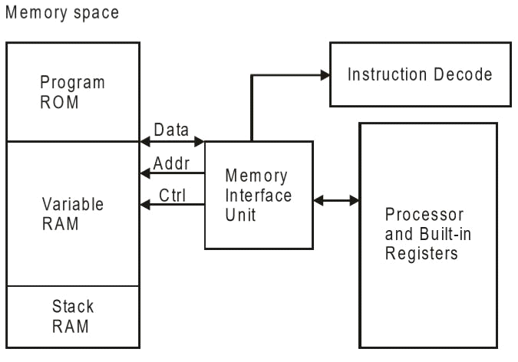

Von-Neumann architecture supports simple hardware. It allows the use of a single, sequential memory. Today's processing speeds vastly outpace memory access times, and we employ a very fast but small amount of memory (cache) local to the processor.

**Harvard Architecture**

The Harvard architecture offers separate storage and signal buses for instructions and data. This architecture has data storage entirely contained within the CPU, and there is no access to the instruction storage as data. Computers have separate memory areas for program instructions and data using internal data buses, allowing simultaneous access to both instructions and data.

Programs needed to be loaded by an operator; the processor could not boot itself. In a Harvard architecture, there is no need to make the two memories share properties.

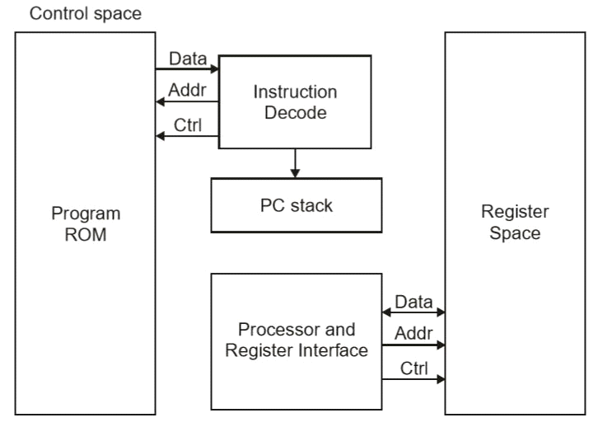

**Von-Neumann Architecture vs Harvard Architecture**

The following points distinguish the Von Neumann Architecture from the Harvard Architecture.

|  |  |
| --- | --- |
| Von-Neumann Architecture | Harvard Architecture |
| Single memory to be shared by both code and data. | Separate memories for code and data. |
| Processor needs to fetch code in a separate clock cycle and data in another clock cycle. So, it requires two clock cycles. | Single clock cycle is sufficient, as separate buses are used to access code and data. |
| Higher in speed, thus less time consuming. | Slower in speed, thus more time-consuming. |
| Simple in design. | Complex in design. |

**Processor**

Processor is the heart of an embedded system. It is the basic unit that takes inputs and produces an output after processing the data. For an embedded system designer, it is necessary to have the knowledge of both microprocessors and microcontrollers.

**Processors in a System**

A processor has two essential units −

* Program Flow Control Unit (CU)
* Execution Unit (EU)

The CU includes a fetch unit for fetching instructions from the memory. The EU has circuits that implement the instructions pertaining to data transfer operation and data conversion from one form to another.

The EU includes the Arithmetic and Logical Unit (ALU) and also the circuits that execute instructions for a program control task such as interrupt, or jump to another set of instructions.

A processor runs the cycles of fetch and executes the instructions in the same sequence as they are fetched from memory.

**Types of Processors**

Processors can be of the following categories −

* General Purpose Processor (GPP)
* Microprocessor
* Microcontroller
* Embedded Processor
* Digital Signal Processor
* Media Processor
* Application Specific System Processor (ASSP)
* Application Specific Instruction Processors (ASIPs)
* GPP core(s) or ASIP core(s) on either an Application Specific Integrated Circuit (ASIC) or a Very Large-Scale Integration (VLSI) circuit.

**Microprocessor**

A microprocessor is a single VLSI chip having a CPU. In addition, it may also have other units such as coaches, floating point processing arithmetic unit, and pipelining units that help in faster processing of instructions.

Earlier generation microprocessors’ fetch-and-execute cycle was guided by a clock frequency of order of ~1 MHz Processors now operate at a clock frequency of 2GHz

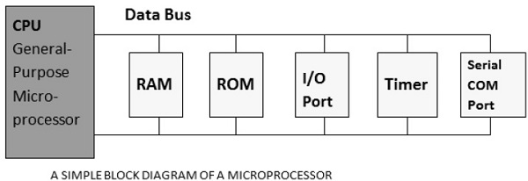

**Microcontroller**

A microcontroller is a single-chip VLSI unit (also called **microcomputer**) which, although having limited computational capabilities, possesses enhanced input/output capability and a number of on-chip functional units.

|  |  |  |
| --- | --- | --- |
| CPU | RAM | ROM |
| I/O Port | Timer | Serial COM Port |

Microcontrollers are particularly used in embedded systems for real-time control applications with on-chip program memory and devices.

**Example of Embedded System**

**Microwave Oven**

The embedded system in a microwave oven works as a command device. It is designed to take directions from the keypad and turn them into commands. If, for instance, you program a microwave oven to operate on high for two minutes, the embedded system triggers the high voltage transformer to operate on full blast for two minutes. When the two minutes expire, the embedded system commands the transformer to turn off. Because the embedded system does nothing more than translate simple commands, it contains relatively simple programming.

**The Two Major Systems in the Microwave**

Two separates but connected systems comprise the microwave's inner workings: The control section and the high-voltage section. The control section channels move electricity safely from the source to the microwave itself. The high-voltage section, then, does the actual work by converting that electricity into microwave rays and emitting them into the main chamber to warm up or cook the food.

Additionally, both the control and high-voltage sections may include sensors or other security devices to prohibit overheating or any other dangerous malfunction that can pose a safety hazard

**Triac**

Part of the microwave oven's control system, the triac is a device that helps channel the electricity from the source – for example, from the outlet through the cord – to the high-voltage system.

By default, this electromechanical relay seals the circuits of the microwave off from the electricity that flows through the outlet and the oven's plugged-in cord. However, when the microwave is turned on, sensors indicate that all the devices are working and ready to produce microwave energy to heat up your food or liquid.

When these conditions are met, the triac then switches into an "on" position. This permits the electrical current to flow to the high voltage transformer.

**High Voltage Transformer**

The high voltage transformer solves a very specific problem. Unique among household appliances, a microwave oven actually requires more power than the normal voltage that your home's electrical wiring produces.

In order to solve this issue, the microwave oven uses a very specific device called the high voltage transformer. The transformer's function is to magnify the power available to the oven from the home's wiring to the level necessary to produce microwaves.

Essentially, the high voltage transformer is a series of capacitors. These capacitors loop the flowing electrical current to make it much more powerful – usually around 3000 volts from the normal 115 volts of household electricity.

**Conclusion**

Embedded systems are rapidly becoming a catalyst for change in the computing, data communications, telecommunications, industrial control and entertainment sectors. Automatic systems in any field will be useful and will save the people and organizations. New innovative applications in these as well as other areas will make embedded systems as one of the fastest developing technology of the near future. Thus, the embedded system plays an important role in our day today life.